EVENT GUIDELINES
ON SITE
• Gallery/Corner: We recommend doing it around the RIVA Table.
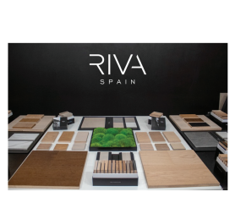
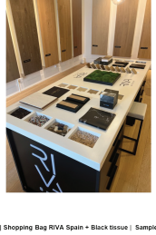
• A&D’s office: We suggest to recreate a RIVA Table using the provided materials. If you need additional ones, please reach out to your Retail Developer.
*These events may or may not include lunch and learn sessions
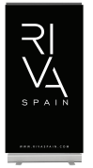
RIVA Table RIVA Table recreation RIVA Banner
EXPOSURE MARKETING MATERIALS
This is the list of samples and marketing materials that you should have on your table but should not be given out
RIVA Wood
RIVA Tile
(1) Wood box swacth samples 12 colors (1) LA RIVA box
(1) Wood A&D samples
(1) Cladding sample
(1) Tile marble binder
(1) Tile cement binder
(1) Tile stone binder
(1) Tile box swacth samples 6 colors
RIVA
Moss
Marketing Materials
(1) RIVA Moss samples
(1) RIVA roll up banner (1) RIVA catalogs
(1) RIVA Tile catalogs (1) LA RIVA catalogs
GIFTS TO ATTENDEES
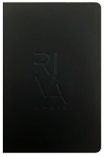
Merchandising
Participants will receive a notebook and a luxury pen.
Samples
Samples for library, minimum upon request
EVENT GUIDELINES
VIRTUAL (GOOGLE MEET)
We recommend having a plain background and the RIVA roll up banner behind the speaker.
We suggest to recreate a RIVA Table using the provided materials to enhance the dynamic presentation.
RIVA Wood
RIVA Tile
(1) Wood box swacth samples 12 colors (1) LA RIVA box
(1) Wood A&D samples
(1) Cladding sample
(1) Tile marble binder
(1) Tile cement binder
(1) Tile stone binder
(1) Tile box swacth samples 6 colors
RIVA
Moss
Marketing Materials
(1) RIVA Moss samples
(1) RIVA roll up banner (1) RIVA catalogs
(1) RIVA Tile catalogs (1) LA RIVA catalogs
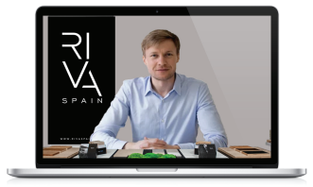Virtual meeting
EVENT GUIDELINES
FOOD & BEVERAGES
If your event requires food and beverages, we suggest including the following items and using these recommended brands:
- Coffee
- Water
- Tea
- Bagels
- Sandwiches
- Fruits

